RESOLUTION NO.__________

RE: CERTIFICATE OF APPROPRIATENESS UNDER THE
PROVISIONS OF THE ACT OF THE PENNSYLVANIA
LEGISLATURE 1961, JUNE 13, P.L. 282 (53
SECTION 8004) AND BETHLEHEM ORDINANCE NO.
3952 AS AMENDED.

WHEREAS, it is proposed to install window signage at 417 Wyandotte Street.

NOW, THEREFORE, BE IT RESOLVED by the Council of the City of Bethlehem that a Certificate of Appropriateness is hereby granted for the work.

Sponsored by: (s)

(s)

ADOPTED BY COUNCIL THIS DAY OF

(s)
President of Council

ATTEST:

(s)
City Clerk

HISTORIC CONSERVATION COMMISSION

CASE # 486 – It is proposed to install window signage at 417 Wyandotte Street.
OWNER/APPLICANT: Andrew & Martha Popichak / Stephen Cunic, Signs by Tomorrow

The Commission upon motion by Mr. Cornish seconded by Mr. Silvoy adopted the proposal that City Council issue a Certificate of Appropriateness for the proposed work described herein:
- The proposal to install window signage at 417 Wyandotte Street was presented by Kevin Garcia.
- The new signage for the window will include a figure logo and read “Titan Insurance, a Nationwide Insurance company” “Garcia’s Agency & Notary, Associate Agent: Kevin Garcia & Miagros Pabon, with telephone and fax number, Auto Insurance, Home Insurance, Life Insurance, Renters Insurance, Notary Services, Title Work, Registration Renewal, copy, Fax, Scan, Print, and Hablamos tu idioma…!Visitanos!” in white, various size lettering as shown in the rendering submitted.
- “Specializing in” and “Also Available” will be removed from the sign to permit more space between the lines above and below the list of services and the list of services.
- The new door signage will be as proposed and read “Garcia’s Agency & Notary, Associate Agent: Kevin Garcia & Miagros Pabon, with Hours and Kevin’s Cell #, and include the Titan Insurance logo.
- The existing neon border around the window, installed by a different tenant, may be retained. Neon lighting and signs were a common feature of the South Bethlehem Downtown Historic District.
- The proposed motion was unanimously approved.

CU: cu

By: 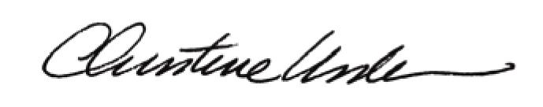

Date of Meeting: February 24, 2014 Title: Historic Officer

